Module 7.2 Assignment
Kobe Alexander
5/22026
Bellevue University
CSD 310

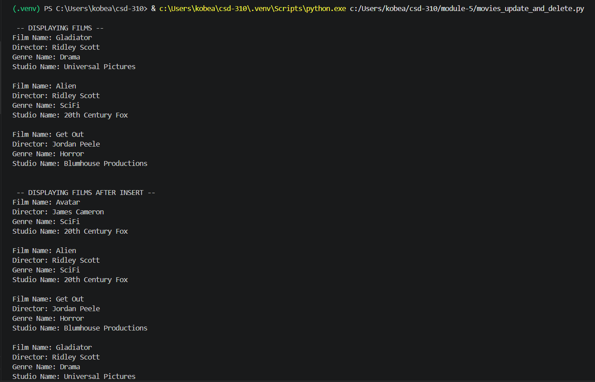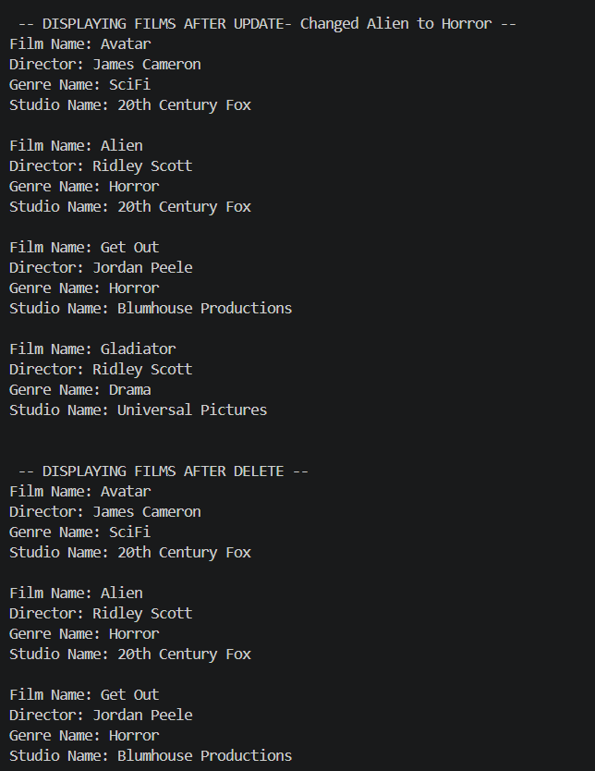

https://github.com/Kobea77/csd-310/tree/main/module-7

